Java Repo:

C:\Java_API\FSE_2019_TaskManager_RestAPI\task-manager

Log File location: C:\Java_API\FSE_2019_TaskManager_RestAPI\task-manager\logs

Tests Execution Status (Local Repo):

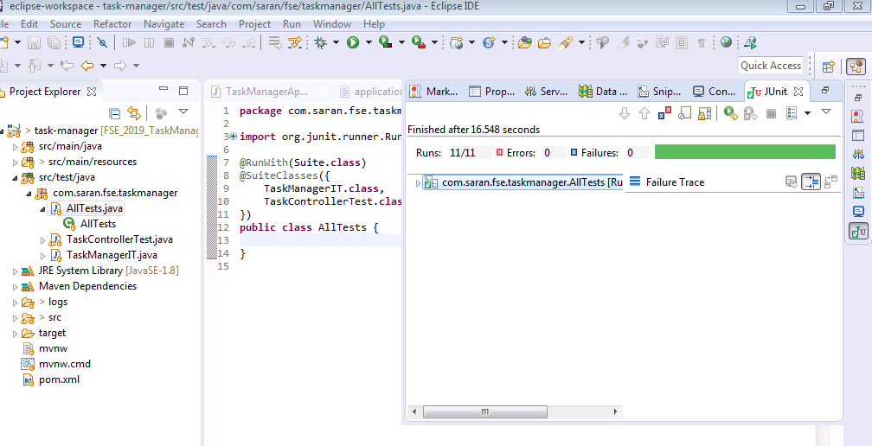

Jenkins Test Execution Status (GitHub Repo):

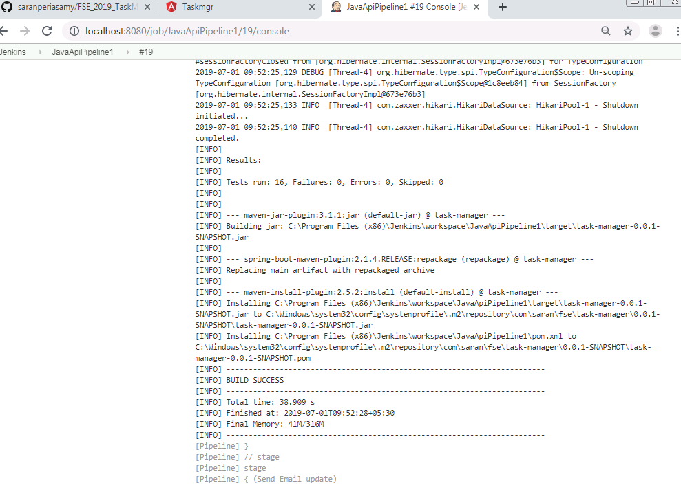

Angular :

C:\FSE_UI\FSE_2019_TaskManager_AngularUI

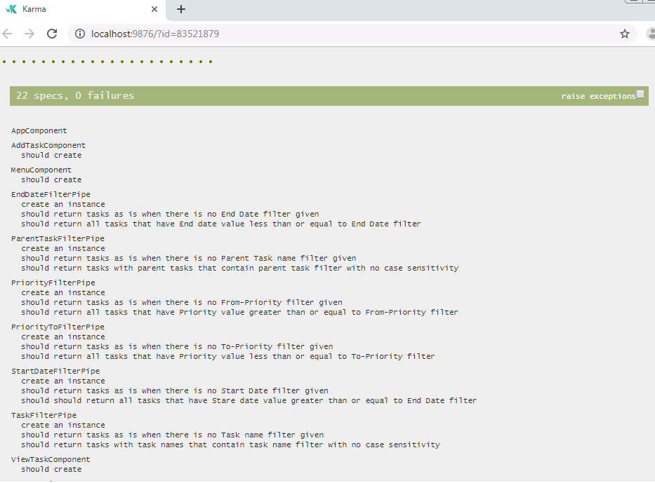

CI/CD Pipeline:

Jenkins runs from:

<http://localhost:8080/>

admin

5c99d6e70dbd4e65bd63a09938963ac4

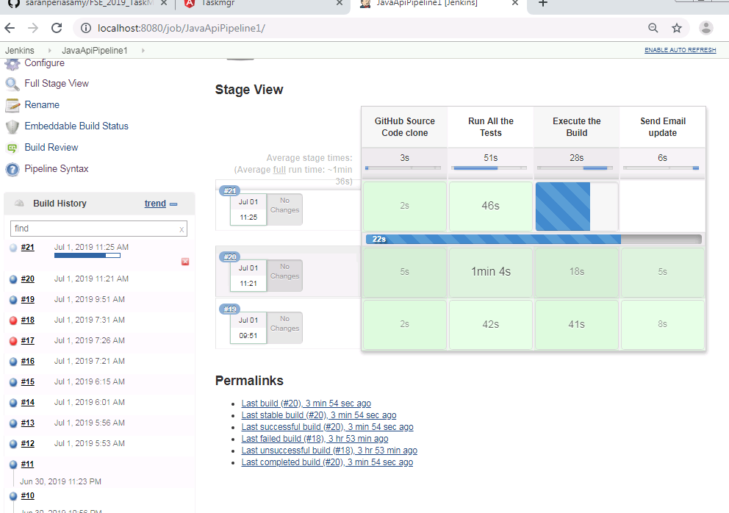

Pipeline script:

node('master') {

stage('GitHub Source Code clone') {

git 'https://github.com/saranperiasamy/FSE2019_TaskManager_Services'

}

stage ('Run All the Tests') {

bat 'mvn verify'

}

stage('Execute the Build ') {

bat 'mvn clean install'

}

stage('Send Email update') {

emailext body: '''Jenkins Build has been executed with the following steps:

1. Retrieve the GitHub Source Code

2. Execute All the Tests

3. Execute the Build

''', subject: 'FSE Task manager Services - Jenkins Build Execueted', to: 'saravanankct06@outlook.com'

}

}